**gprof assignment**

1. **Refer the code in “recursion_example.c”. Using gprof , generate the flat profile and call graph and interpret their contents.**



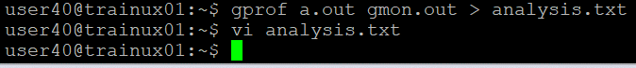

the gmon.out is created.

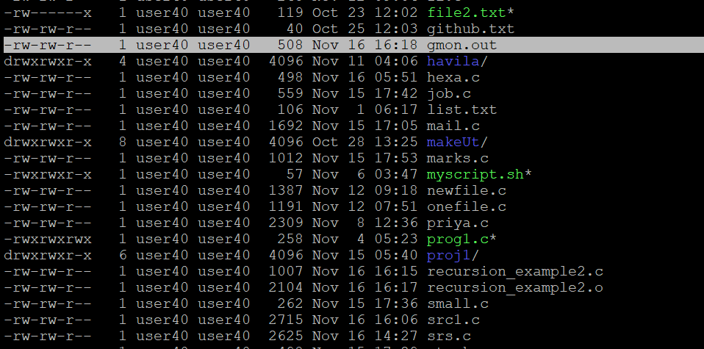

**FLAT PROFILE:**

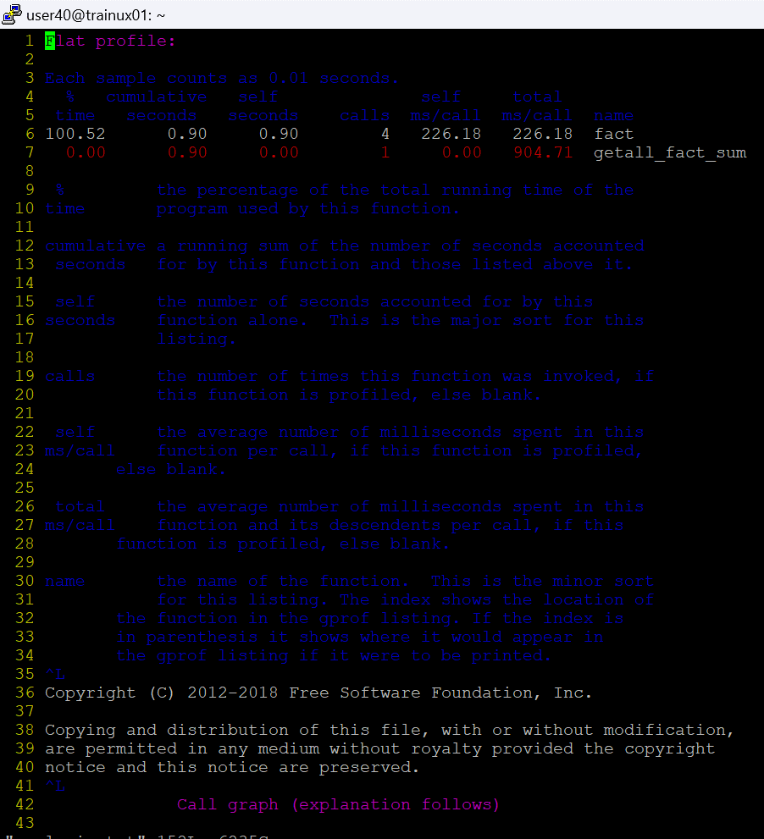

**CALL GRAPH:**

